AT MEGA 32 BASED
Witness Camera
ABSTRACT AT3267

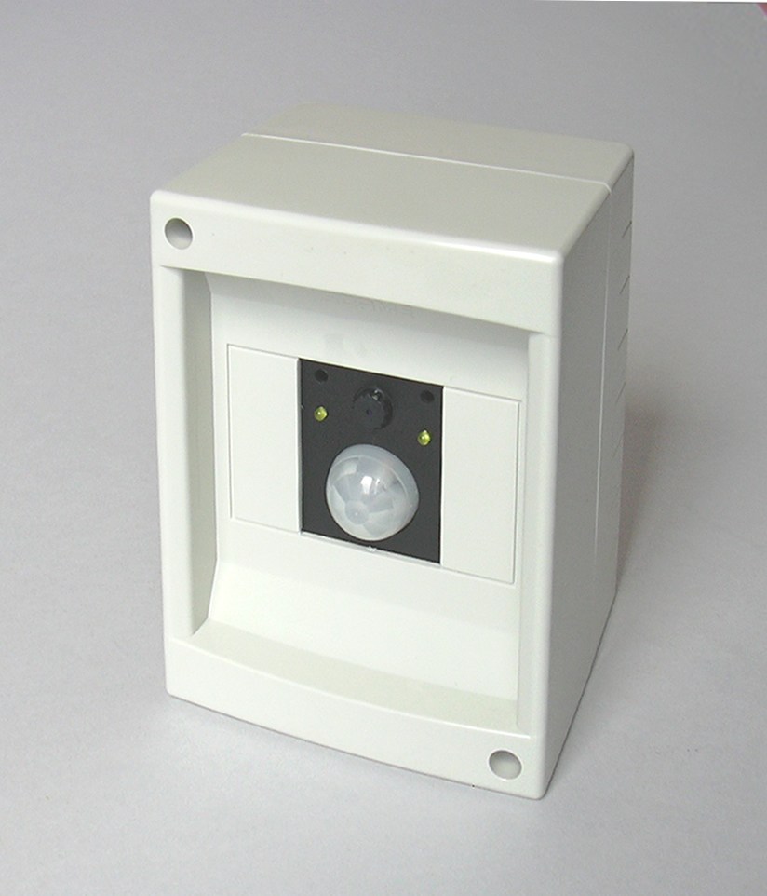
The Witness Camera is an automated, self-recording surveillance camera, that uses a gigabyte-class flash card as recording media.
I designed the Witnesscam because available surveillance solutions were too expensive or impractical for home use.
I built the system from a VGA CMOS colour camera, a passive-infrared (PIR) movement sensor, an ATmega32 processor, and a 1GB SD-card.
The prototype looks like an ordinary alarm detector. But when it detects people moving around, it silently starts recording.
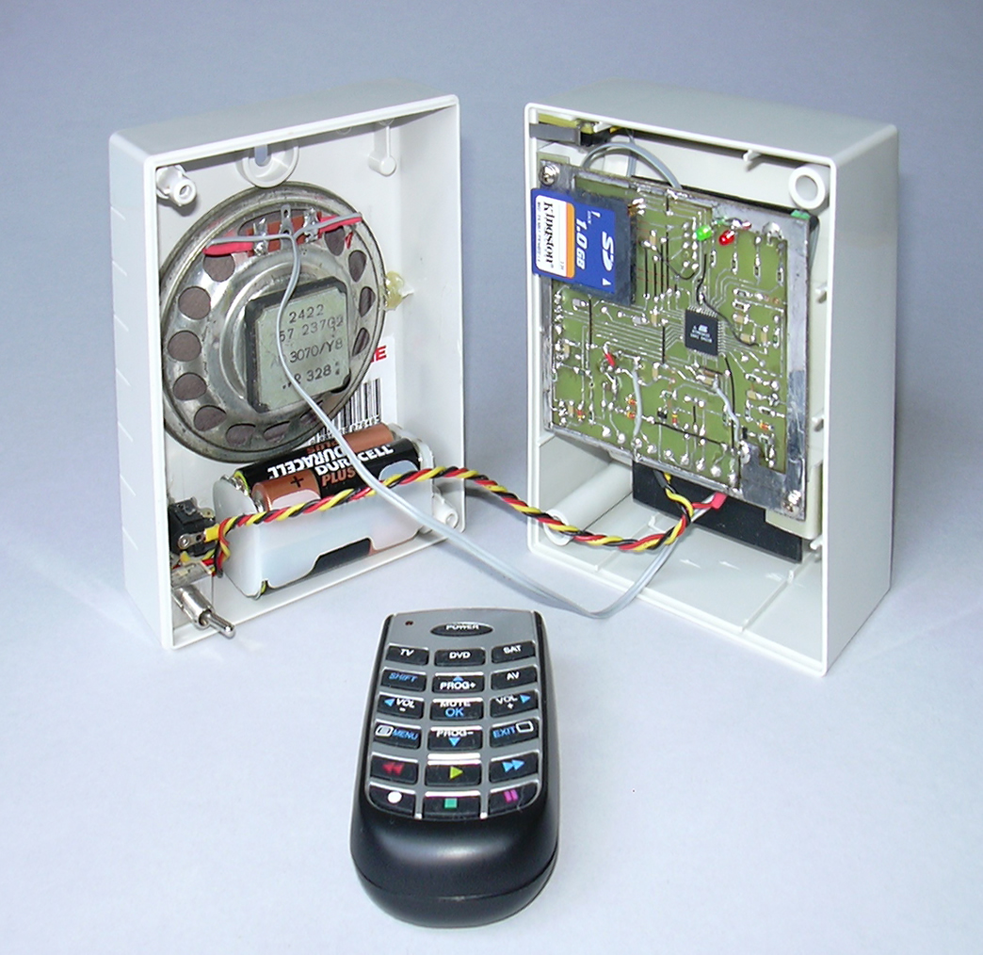
A 1 GB card can store 50,000 colour frames, with a definition similar to industrial VHS-CCTV recorders (320x200), taking a new picture every 2.5 or 3 seconds. On most typical domestic environments, this translates to more than one month of images before overwriting the oldest frames.
The Witness Camera features also a high resolution mode, taking pictures at 640x480 pixels every 3.5 or 4 seconds. Thanks to embedded image compression, the same card can contain as much as 25,000 frames when high-resolution is selected.
The recording system is flexible, allowing to choose between PIR activated, timer, continuous and externally triggered recording modes. You can decide what intervals to use and how many extra frames to take after a trigger ends.
Creating new applications, like an automatic door capable of taking snapshots of persons entering a building, or using it as an in-vehicle recorder, is simply a matter of selecting the operating mode and connecting a trigger source.
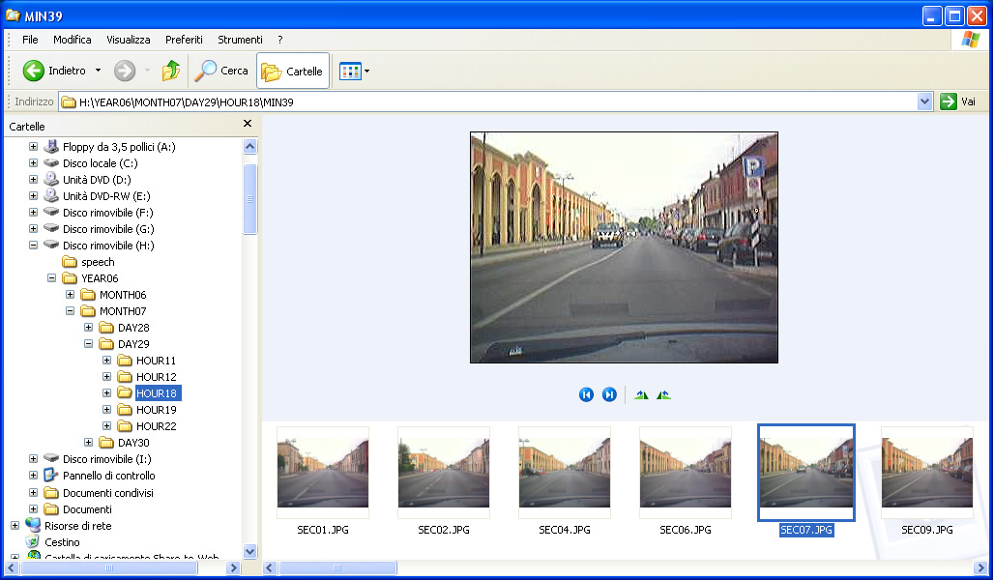
The system supports a standard file system (FAT16 or FAT32), and image compression format (JPEG). It sorts the pictures in an human-readable structure, grouping them in folders according by date and time.
Therefore, in the unlikely event you need to inspect the pictures, just take off the card from the camera and put it into a PC. No special software is required other than Windows XP default browser.
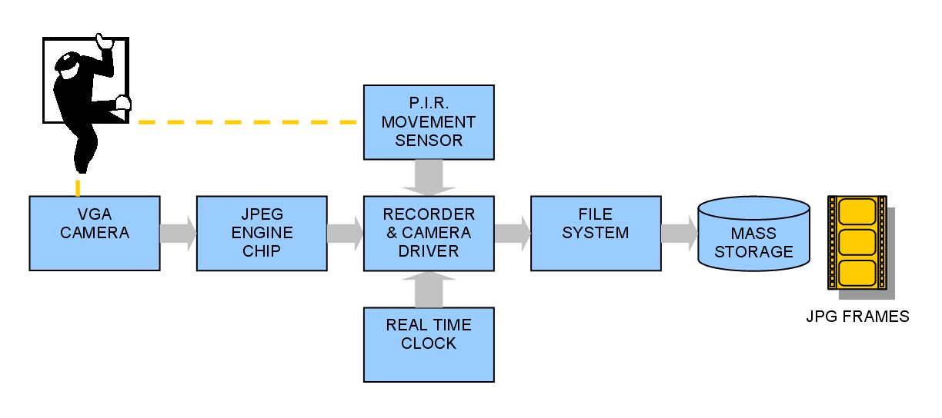
Fitting all the required functionalities inside a small 8-bit microcontroller is an impressive achievement. The design exploits the potential of the ATmega32 to a large extent: almost every hardware feature of the AVR finds practical application. This reduces the number of the parts required by the design, which is a very optimized one.
The Witnesscam is inexpensive – dramatically inexpensive when compared to the currently available off-the-shelf surveillance camera & time lapse recorder pair. This results from a lean bill of materials, but also from leveraging on mass-produced parts from markets like mobile telephony (JPEG camera) and music players/digital photography (flash card).

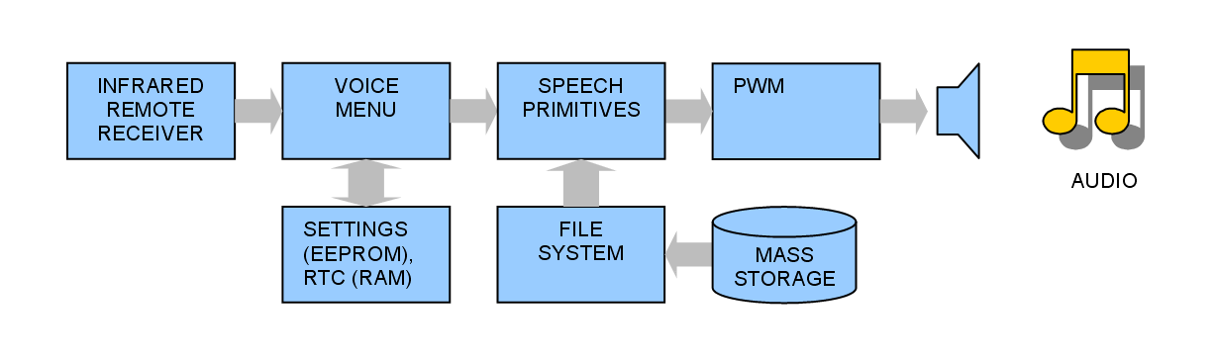
The design focused also on ease of use. Users can control the camera by means of an infrared remote. The camera responds with voice prompts, which is handy (and cool!), because surveillance cameras are usually placed in out-of-the way places like ceiling corners. Also, the circuit recognizes when the box is opened for taking off the card, and signals when it’s safe to remove it firing a green LED.
The firmware fits perfectly the available amount of FLASH and RAM. Most code modules - like voice-prompt menus, or automatic logging of files in folders according to date and time - are suitable for reuse in many different projects. Use of BASIC language (because of the availability of a known-good FAT library for driving SD-MMC cards) doesn’t rule out a structured architecture and good programming practices!

'**************************************************************************************
'*
'* Get disk parameters and reset archive status.
'* This routine is meant to be called when a disk change is detected,
'* or when the system is powered-up.
'* At power up, attempts setting the clock according to the time of most recent file,
'* and salutes users with a system settings summary.
'* Logs disk parameters on I/O stream #1 (connect to PC serial port for debug)
'*
'**************************************************************************************
sub diskInsertion()
local errorCode as byte
diskInitialized = FALSE
print #1 , "Initialize disk... ";
Gbdriveerror = driveinit()
if Gbdriveerror = 0 then
print #1 , "Initialize File System ... ";
' Select partition 1 (or use 0 for drive without Master Boot Record)
errorCode = initFileSystem(1)
if errorCode <> 0 then
print #1, "Error: " ; errorCode ; " while initializing file system"
else
print #1, "File system type: " ; Gbfilesystem
print #1, "FAT Start Sector: " ; Glfatfirstsector
print #1, "Root Start Sector: " ; Glrootfirstsector
print #1, "Data First Sector: " ; Gldatafirstsector
print #1, "Max. Cluster Nummber: " ; Glmaxclusternumber
print #1, "Sectors per Cluster: " ; Gbsectorspercluster
print #1, "Root Entries: " ; Gwrootentries
print #1, "Sectors per FAT: " ; Glsectorsperfat
print #1, "Number of FATs: " ; Gbnumberoffats
print #1, "Disk size: "; disksize(); " kB"
print #1, "Disk free: "; diskfree(); " kB"
diskInitialized = TRUE
call initializeArchive()
call beep()
waitMs 200
if clockIsSet = FALSE then ' Upon reset, clock settings are gone,
call dateTimeGuess() ' so try to guess current date and time
clockIsSet = TRUE ' based on the last file found.
call say( "GREETING" ) ' Tell the audience we're alive...
call sayStatus() ' ...and give a summary of current settings.
endif
end If
else
print #1 , "Error during Drive Init: " ; Gbdriveerror
end if
end sub

